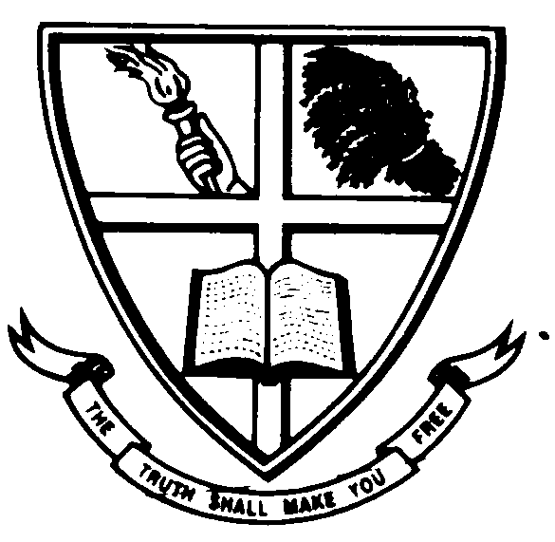 **UNION CHRISTIAN COLLEGE, ALUVA-683102**

**ALL KERALA INTER COLLEGIATE ELOCUTION AND QUIZ COMPETITIONS**

**All Kerala Inter Collegiate Elocution (English and Malayalam) competitions for the Prof. E. Narayanan Nambiar Memorial Ever-Rolling Trophies and All Kerala Inter Collegiate Quiz competition for the Prof. A.K. Abdul Kareem Memorial Ever- Rolling Trophy**

**DATE: 5th November, 2014**

**Registration time: 9.30 a.m.**

**Venue: VMA Hall, U. C. College Aluva-2**

**Contact: 0484 2609194, 9847513132**

**For Rules, Regulations and Prize money details log on to www.uccollege.edu.in**