14TH DR. M.V.KURIEN COMMEMORATIVE LECTURE 2018

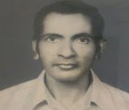

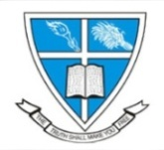

**Research & Post Graduate Department of Economics**

**Union Christian College, Aluva**

*cordially invites you to be with us on the occasion for sharing the grateful remembrance of Late Dr. M.V Kurien (Former Head of the Department of Economics)*

ADAM SMITH AND HIS CONTEMPORARY RELEVANCE

Date : Friday , February 1, 2019

Time : 10:00 am

Venue : T B Ninan Hall

Dr. Alex M Thomas

Assistant Professor

Department of Economics

Azim Premji University

Bangalore

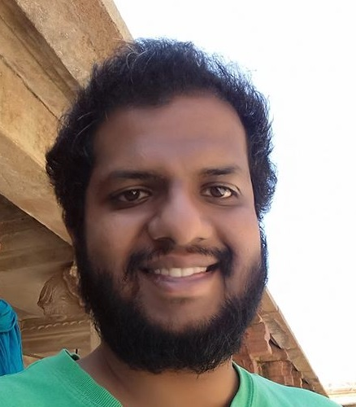

**Dr. M. V. Kurien**

**Mannakunnil Varghese Kurien** was born at Pullad in the present Pathanamthitta District. He had his schooling at the Mar Thoma High School, Kozhencherry, and moved to C M S College, Kottayam for his Intermediate Course. He joined U. C. College for his undergraduate studies (1951-53). This was followed by a three year stint of teaching at the Mar Thoma High School, Ranni. In 1956 he joined Kerala University for his Postgraduate studies and took his MA Degree in 1958. In the same year, he joined the Faculty of U. C. College. Six years later (1964) he left for the USA for research and higher studies. The St Louis University, Missouri, awarded him the degree of Doctor of Philiosophy (Ph.D.) in 1970 for his monumental work ‘An evaluation of American Food Aid to India during 1956-1967’. Dr. Kurien returned to U C College in 1970.

Dr. M.V.Kurien had a significant role in starting the graduate and postgraduate programmmes in Economics in the College. He served the college with great distinction in various capacities such as Professor and Head of the Department of Economics, Superintendant of Works, Bursar, Warden, President of the Planning Forum, President of the Social Service League, President of the CSI Congregation, and Advisor to the SCM. Dr Kurien was a great mentor. He loved his students and co-workers, and was always a friend, philosopher and guide to them. He was a scholar and teacher of deep integrity – a great Guru. He lived a life true to the founding ideals of U.C. College.

Dr. Kurien retired from active service in 1988 and passed away on December 26, 1996.

Wife: Late Mrs. Mary Kurien

Children: Varghese Kurien, Sneha Kurien and George Kurien

**Dr M.V Kurien Memorial Lectures - Past Years**

|  |  |
| --- | --- |
| Dr M.A Oommen | Globalisation & Asian Crisis |
| Dr Thomas Issac | Decentralized Planning |
| Dr Susan Thomas | Financial Sector Reforms |
| Mr C.J George | Commodities & Derivatives |
| Dr B Ekbal | IPR & Human Rights |
| Dr Venkatesh Athreya | Food & Nutrition Security in India |
| Dr K.P Mani | Approaches to the Twelfth Five Year Plan |
| Dr N.J Kurian | Economic Development Vs Social Development |
| Dr Rajan Gurukkal | Knowledge Economy and India |
| Dr. K K George | Tectonic Shifts in Kerala Society & Economy(2015) |
| Dr. Michael Tharakan | Democratization and Peoples’ participation in programmes for reducing deprivation in education : A study with reference to Keralam.(2016). |
| Dr Vinoj Abraham | Casualisation of labour in the formal manufacturing sector in India(2017) |
| Mr Siddhik Rabbiyat | Firms as a source of market failure: An institutional perspective(2018) |

**Prof. Sunil Abraham Thomas Dr. Thara K Simon**

Head of the Dept Principal